North-West University |

Class Diagram Assignment

CMPG 223

Bongani Tabu - 32234147

Tebogo Setona - 28910273

Renier Smith - 35024968

Alwyn Barnard - 32033303

Mecaylla Beukes - 28331869

Thabo Khoza TN - 35639407

Scope for National Park

The system must include functionality for the following:

* Maintenance of Activities (Booked and Cancelled).
* Maintenance of guests.
* Make a booking,
* Cancel a booking.
* Change a booking.
* Change an Activity Type.
* Detailed reporting such as: Monthly expenses and income report, Client report, Past transactions report, Activity income. Reports income per period.

Use-Case Model for National Park

National Park System

Log into System

Maintain Animals

**Administrator**

Data Model for National Park

|  |  |
| --- | --- |
| GUESTS | |
| PK | Guest_ID |
|  | Guest_Name |
|  | Guest_Surname |
|  | isChecked_in |
|  | Email_Address |

|  |  |
| --- | --- |
| Activity | |
| PK | Activity_ID |
|  | Activity_Duration |
|  | Activity_Price |
|  | Activity_Capacity |
|  | Activity_Area |
| FK | Activity _Type |

|  |  |
| --- | --- |
| BOOKING | |
| PK | Booking_ID |
|  | Booking_Date |
|  | Booking_Payment |
|  | Guest_Arrival |
|  | Guest_Departure |
| FK1 | House_Number |
| FK2 | Guest_ID |
| FK3 | Activity_ID |

|  |  |
| --- | --- |
| GUEST_HOUSE | |
| PK | House_Number |
|  | House_Type |
|  | House_Area |

Process Model for Maintain Bookings

System User

Booking_Date

Guests’ Requested Booking

Maintain Bookings

**New Booking:**

**Cancel Booking:**

**Change Booking: (Read)**

1{Booking_Date + Cancelled_Booking + Changed_Booking + Booking_Payment + Guest_Arrival + Guest_Departure + House_Number + Guest_ID }N

1{ House_Number + House_Price + House_Type +

House_Area }N

1{ Booking_ID + Booking_Date + Cancelled_Booking + Changed_Booking + Booking_Payment + Guest_Arrival + Guest_Departure + House_Number + Guest_ID }N

1{Booking_ID}N

|  |  |
| --- | --- |
| D3 | Guest House |

|  |  |
| --- | --- |
| D2 | Guests |

1{ Guest_ID + Guest_Name + Guest_Surname }N

|  |  |
| --- | --- |
| D1 | Booking |

**Change Booking: (Write)**

1{Booking_ID + Booking_Date + Cancelled_Booking + Changed_Booking + Booking_Payment + Guest_Arrival + House_Number + Guest_ID }N

Process Model for Maintain Activities

System User

Activity_Type, Activity_Area

Maintain Activities

**Add Activity: (Booked)**

1{ Activity_Type + Activity_Area + Activity_Duration + Activity_Capacity}N

**Remove Activity: (Cancelled)**

1{ Activity_ID}N

|  |  |
| --- | --- |
| D4 | Activities |

Process Model for Maintain Guests

System User

1{ Guest_Name + Guest_Surname }N

Request to Maintain Guests’ Details

Maintain Guests

1{ Guest_ID + Guest_Arrival + Guest_Departure}N

**New Guest:**

**Delete Guest:**

1{Guest_Name + Guest_Surname }N

1{Guest_ID}N

|  |  |
| --- | --- |
| D1 | Booking |

|  |  |
| --- | --- |
| D2 | Guests |

ER Diagram

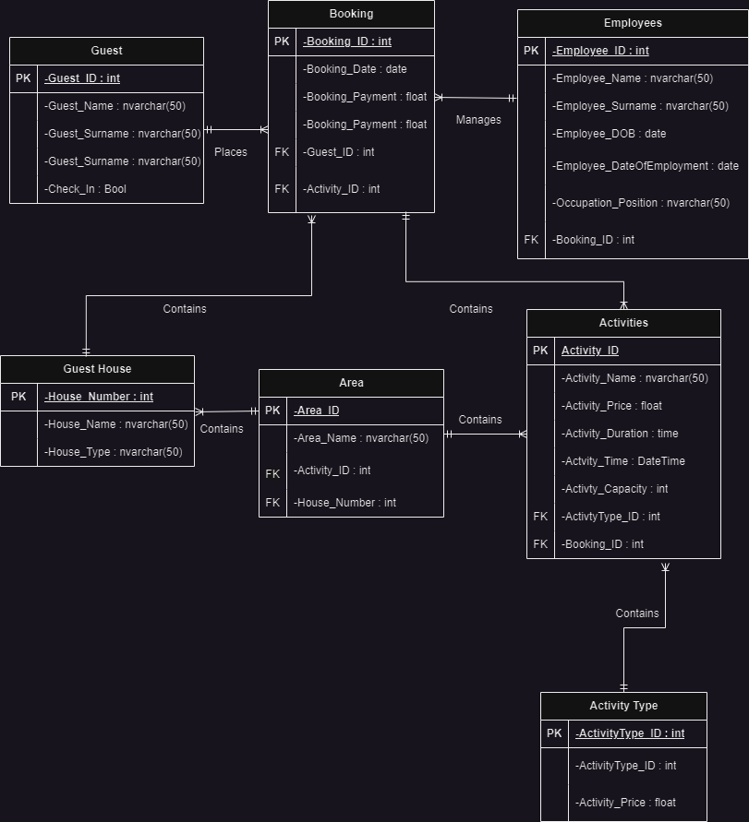

Class Diagram

